1. **Use Sakila Table**
2. **Check the tables:**

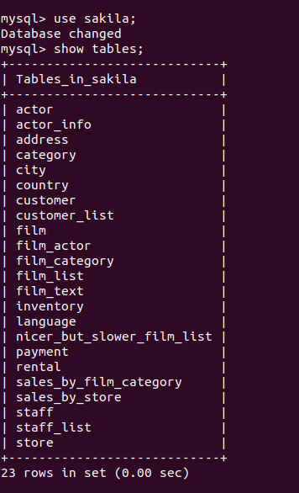

**3. Display top 5 highest popular movies -**

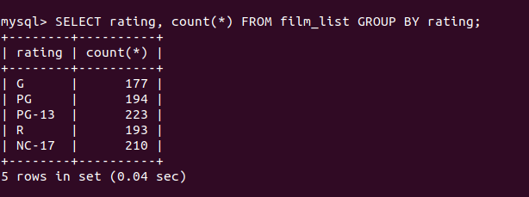

**4. Display the actor details along with number of movies:**

SELECT a.actor_id , a.first_name, a.last_name , Count(f.film_id) as NumberOfMovies

FROM actor as a JOIN film_actor as f

ON a.actor_id = f.actor_id

GROUP BY a.actor_id;

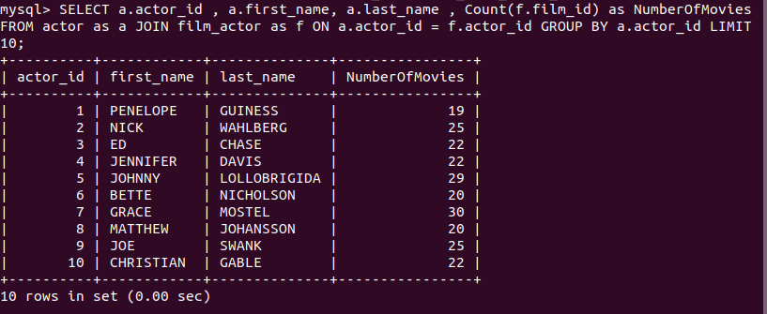

**5. Display number of movies released every year -**

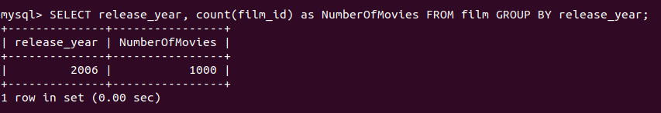

**6. Display the movies where the name starts with a and ends with r -**

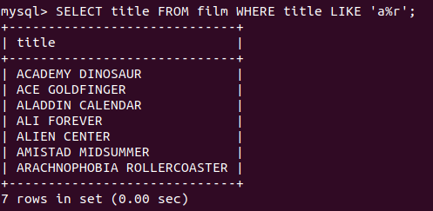

**7. Display the total no of movies -**

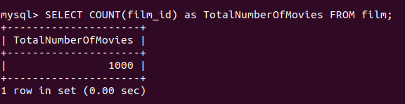

**8. Display the most and least expensive movies -**

* Least Expensive Movies are as below:

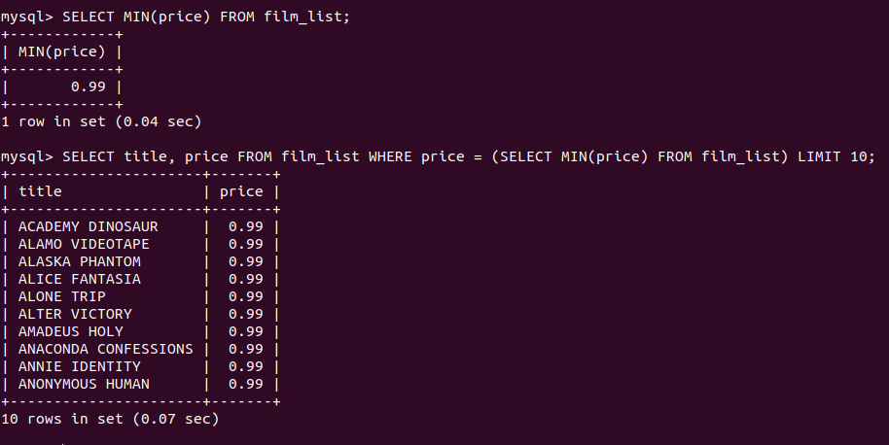

* Most Expensive Movies are as below:

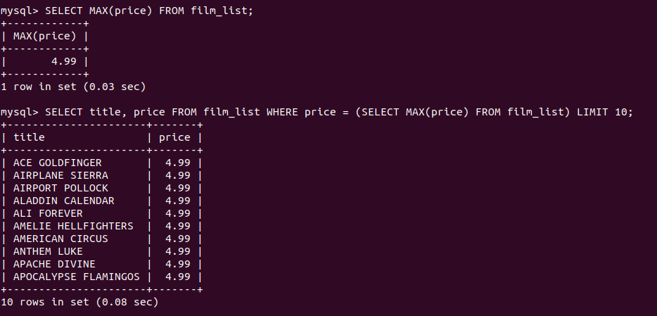

**9. Display the rental for each movie -**

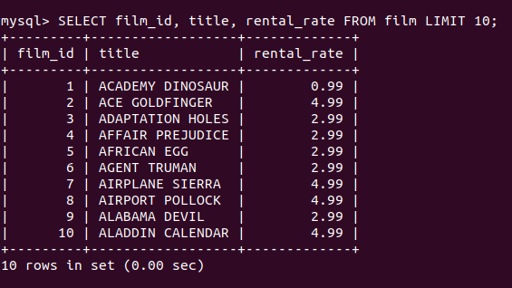

**10. Display the amount paid by every customer -**

